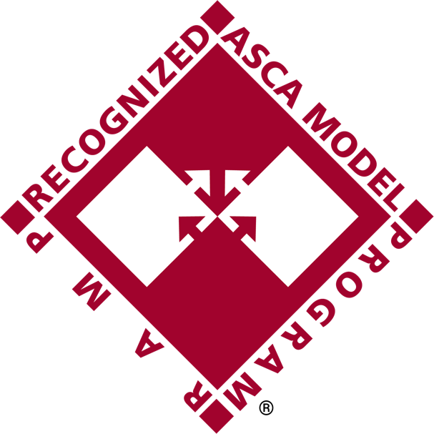

RAMP® Application Signature Page
Purpose
The signature page is an acknowledgement by your school counseling team, advisory council, school board representative and principal of your school counseling program’s work and application for national recognition. The completed form of original signatures should be uploaded in Section 7 of the fifth edition application portal. The school board representative should be the elected official. Although the superintendent’s signature can be included, it does not replace the school board representative’s signature.

Original handwritten signatures are preferred. Electronic signatures can be used to resolve unique situations. An application with an electronic handwriting feature must be utilized. Some app examples include:
- Adobe Acrobat
- DocuSign

Best Practices
- Secure signatures during the second-semester advisory council meeting.
- Contact your school board representative well in advance of the October deadline.
- Ask your principal to assist you with reaching out to your school board representative if there are specific policies and procedures for communication with a school board member.

RAMP® Application Signature Page
By signing this page, I confirm that I am aware of and supportive of the school counseling program’s work to influence student achievement outcomes through ASCA National Model® implementation, as well as the endeavor to earn national recognition from the American School Counselor Association.

Name/Role | Signature | Date

Principal Name | Signature | Date

School Board  Representative Name | Signature | Date

